
GIS Library Tutorials – Introduction to ArcGIS Online - 5

Layer Attributes: Creating a Thematic Map and Adding Labels
In this practical example, we are going to create a thematic map of Wood Types for the Republic of Ireland. We are going to use data in the ancient and long-established woodland attributes table to colour code the layer according to the types of woodland.

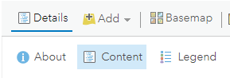
Left click on the Details tab and then left click on the Content tab to show the layers of data now in your map.

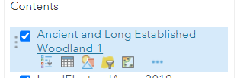
Hover with your mouse over the ancient-long-established woodland name – the background colour changes to blue and then left click on the symbol for the Attribute Table

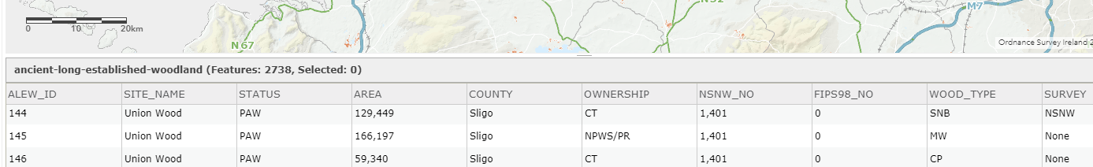
Just below the map, the table opens, and you will see a column named Wood_Type.
These codes refer to the different categories of woodland types.

From the metadata provided in the PDF which accompanied the files we can read
that the categories used were :

semi‐natural broadleaf (SNB) mixed woodland (MW) conifer plantation (CP)
non‐native broadleaf (NNB) recent clearfell (RC)

We are going to use the information in this column to create a thematic map.
In other words, this is the data we are going to symbolise. To close the table left click on the small x in the top right corner of the table.

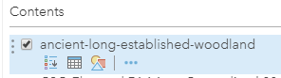
Left click on the Change Style symbol

Under Choose an attribute to show left click on the pull-down arrow
Scroll down to Wood_Type and left click on this to select it

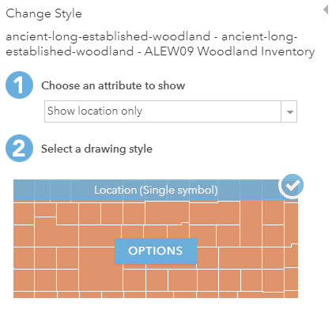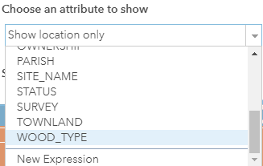
On the map zoom in with the + button (or with your mouse) on any part of the country where you can see some woodland
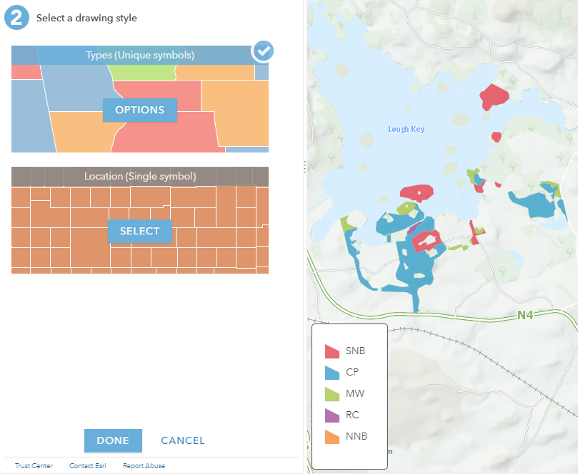
As you zoom in you will see a default set of colours visualising the different Wood Types
A legend will also appear on the map
To change the default colours left click on OPTIONS

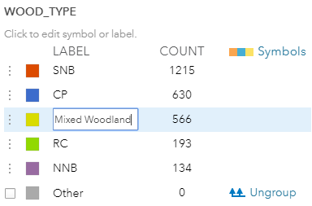
In the LABEL column you can rename the item

Left click in a label name type in the new name and press return / enter key

Left click on Symbols to change their colours
If you cannot see the Symbols column left click on the three vertical dots along the edge of the map
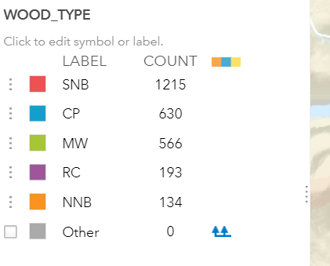
A double-sided arrow appears

Left click on this arrow, hold your mouse down and drag the arrow to the right until the Symbols column appears

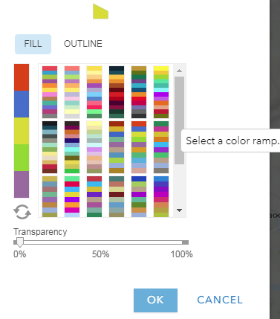
Left click on the colour ramp of your choice and then left click on OK to change the Wood Type colours shown on your map

The colours on the map will update with your new selection
To change a single colour – left click on the colour – this opens the colour palette – left click
on the new colour of your choice

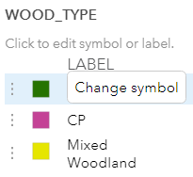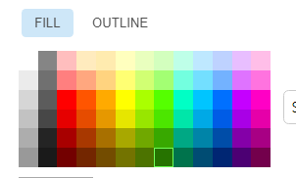

When you have clicked on OK and that screen closes, it brings you back to the previous
Window, left click on Done



ADDING LABELS

You can also use the data from the attribute table to add labels to your map.

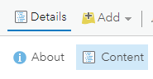
Left click on Details

Then left click on Content

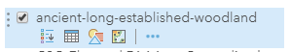
Hover over the dataset which has the features you want to show labels for

Then left click on Content

Left click on the 3 blue dots. This is the icon for More Options

Then left click on Content

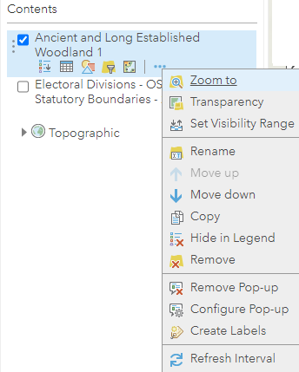
From the menu which opens left click on Create Labels

Then left click on Content
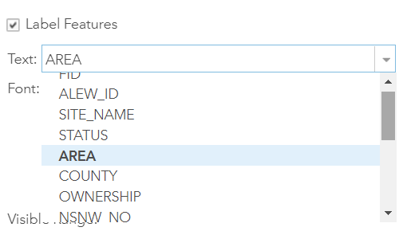
The Label Features box should be checked - if it has no tick in it, left click in the Label Features box so tick appears

Then left click on Content
At the Text field, left click on the arrow for the pull-down menu to see the features you can choose from

Left click on the feature you wish to label (AREA in this example)
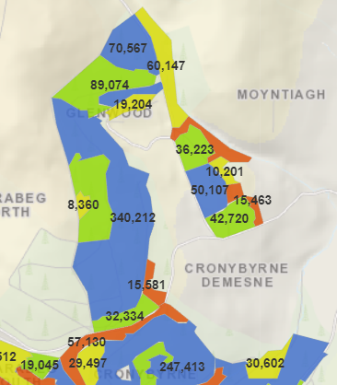
The labels will be immediately shown on the map

To save the labels to the map, left click on the Save button above the map
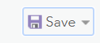

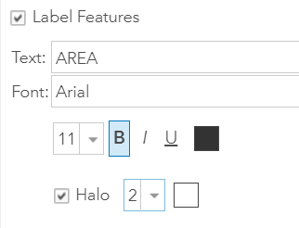
You can change style, e.g., font, colour of the text on the label and size of the font

Left click in the checkbox to add a halo effect around your label text.

You can also choose the width and colour of the halo.

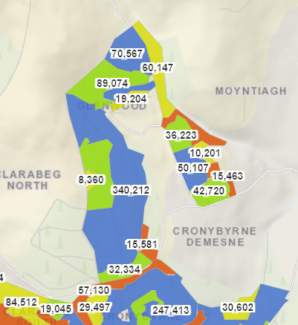
This example shows a white coloured halo effect around black text.

Left click on OK to apply this
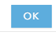

For further information about labelling and advanced features see:

https://doc.arcgis.com/en/arcgis-online/create-maps/create-labels.htm

and this YouTube video ArcGIS Online : Web Mapping with Arcade Expressions

https://www.youtube.com/watch?v=2Rg15OshGb4

